**GITHUB LINK :** <https://github.com/khadijayadi/khadijayadi/blob/main/HAMSTERSTER_network_anlysis_.ipynb>

**Data Driven-strategic management: Hamsterster social platform interactions**

**Introduction:**

This study uses the social networking platform Hamsterster, a social community of users with various social relations among them, including family and friend relationships. The website structure is reflected in this dataset, where users are nodes and edges formed by their social relations. The undirected, and unweighted network reflects the dynamics of social interactions within the community.

**Data collection and pre-processing:**

The dataset for this analysis consists of 2,426 nodes, each representing a user on the Hamsterster social network. To make the analysis smoother, the dataset was loaded into a Pandas DataFrame ,as shown below, where each row is a connection between two users, and columns "Hamsterster ID" for the node and "Connected to" for the corresponding linked user. The data was then transformed into a NetworkX graph for analysis.

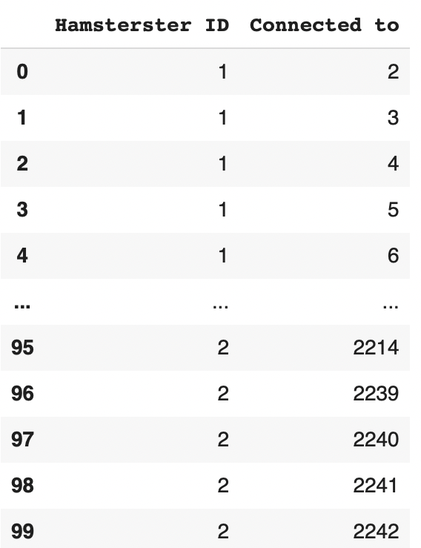

**Network construction and visualization:**

The hamsterster social network graph below consists of 2,426 nodes and 16,630 edges . As an initial analysis of the structure, we can note that the network reveals a highly connected dense core indicating a strongly interconnected group surrounded by a more sparsely connected periphery forming a ring like structure .

This suggests that certain users in the network have a high number of interactions between different parts of the network. However, some other users with fewer connections possibly interacting only with the same one or two users in the network.

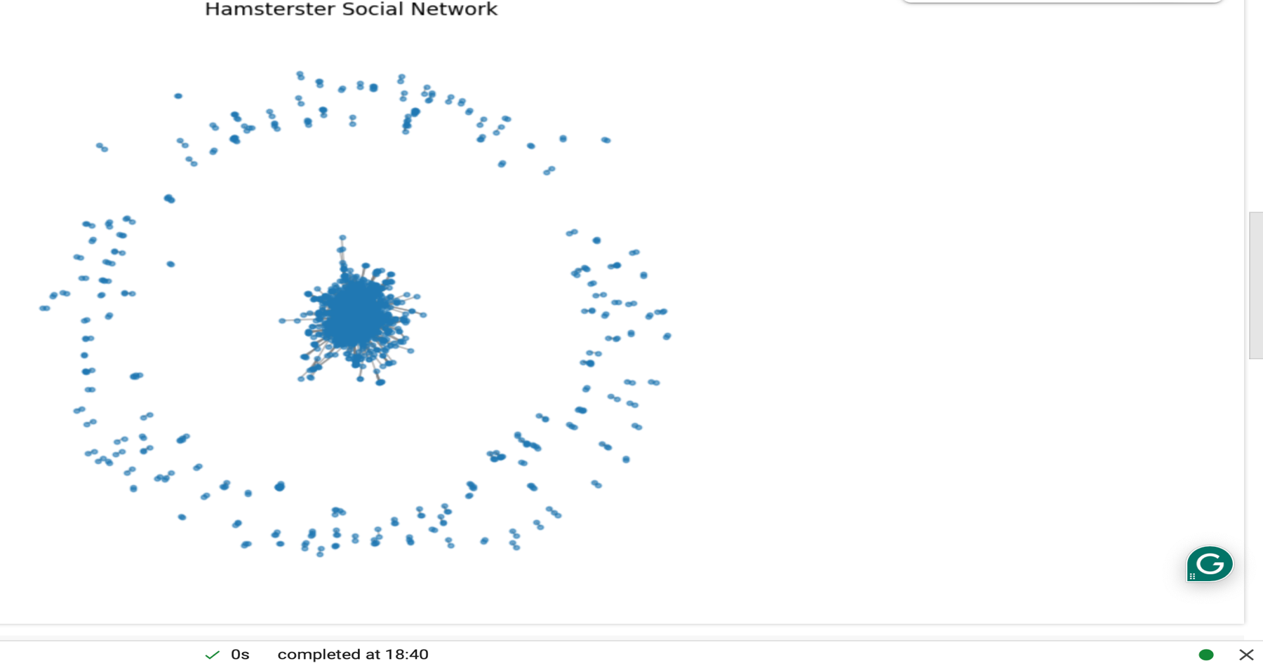

**Network Analysis :**

1. **Degree Distribution Analysis :**

From the following graph of nodes degree distribution , we can observe that the network is right-skewed, where most nodes have few connections, while a small number of high-degree nodes which are the hubs, are highly connected.

Knowing that this is a common pattern for real-world social networks, where the interaction is mediated by a few highly influential individuals, it is plausible that the network is scale-free. Further, we observe that while high degree nodes are rare, they play a very critical role in maintaining network connectivity. These hubs are crucial to information flow, and the network would be largely fragmented without them.

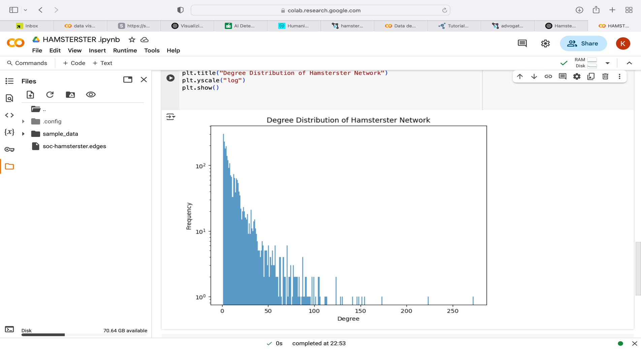

1. **Connected Components, Clustering Coefficient and Diameter Analysis**:

The code Outputs:

Number of Connected Components: 148

Size of the Largest Connected Component: 2000

This explains that even though the network is scattered, a significant number of users are connected within a large connected group.

the diameter:10

the clustering coefficent:0.5375333362074072

From these results, we can see that the longest shortest path between any two nodes in the largest connected component is not very long, as indicated by its diameter of 10. This means that even in a large connected component, the network is quite well-connected, and users generally have to make only a small number of steps in order to reach one another.

The network is weakly disposed toward user clustering, as indicated by its clustering coefficient of 0.538. That is, clustering is not excessively high, though there is some degree of localized cohesiveness to the network. Users of the same social group are slightly more likely to be connected with each other, meaning that the Hamsterster website possesses some close-knit groups .

1. **Path Analysis :**

The path analysis was divides into two steps in order to obtain informative data on the structure and connectivity of the Hamsterster social network.

I first computed the globally shortest path between 2 nodes in the entire network. We see that node 1 and node 2 are directly connected, and their shortest path is 1. This observation indicates that, as is the case for general social networks, the network has tightly connected node pairs.These extremely short paths, however, are not necessarily representative of the network's normal experience.

In the second step, I examined the shortest path of two particular, non-random nodes out of the set of joined components: node 1 and node 2368.:

The code output :

Shortest path from 1 to 2368: [1, 6, 53, 2364, 2368]

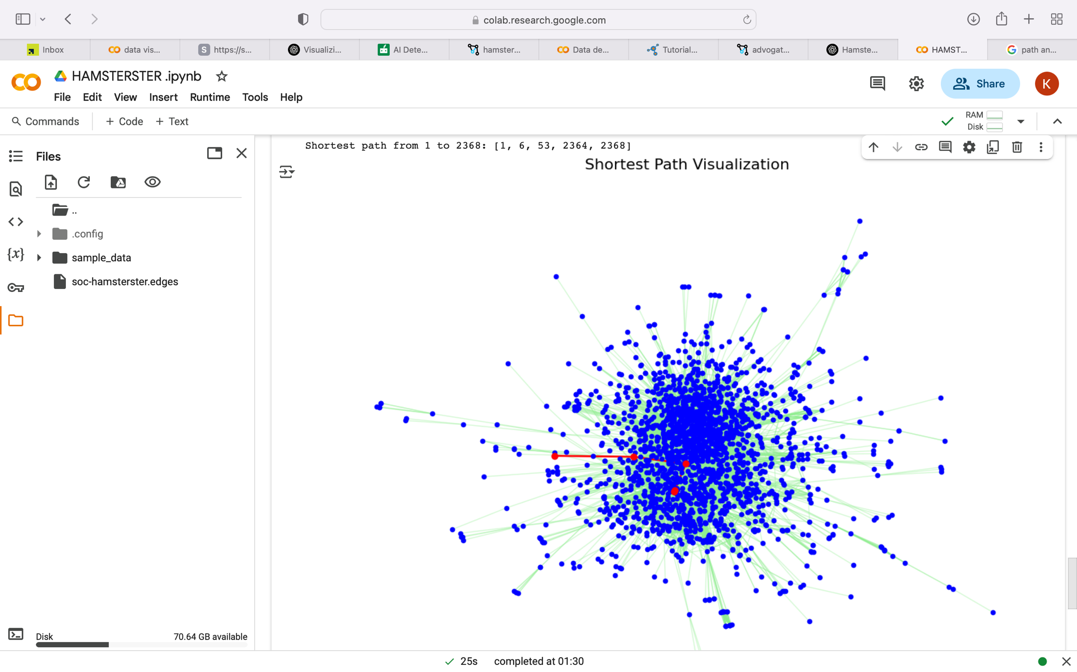

Let’s analyze the results together:

• **Node 1**: This is where the journey of the traversal starts. (**source node**)

• **Node 6**: the first neighbour of node 1 acting as an initial step in the traversal

• **Node 53**: A mid-path connector, helping bridge the gap between two distant parts of the network.

• **Node 2364**: A key intermediary that links toward the final destination.

• **Node 2368**: This is the **target node** of our shortest path.

By doing so, the four-edge pathway increased and became more descriptive. Such a picture fully reflects the interaction likely between various parts of the network. An attribute of small-world behaviour, it shows the way that nodes that are not directly connected may still pass information to one another by means of a relatively short series of intermediary links.

1. **Density Analysis :**

To measure the level of connectivity in the Hamsterster network, I calculated the network density using the density function from NetworkX library . The final density was 0.008053, which is expected for a large social network even though it is still fairly low. Most of the users (nodes) are connected with only a small componenet of the other users .

However the dense clusters in the network and the short paths allow for fast exchange of information.

One of the characteristics of real-world social graphs is that the network is sparsely connected but still easily traversed.

1. **Centrality Analysis:**

To identify the most influential 10 nodes in the Hamsterster network, we calculated the Four centrality measures: PageRank, eigenvector centrality, betweenness centrality, and closeness centrality. Each of these measures identifies one distinct facet of a node's centrality in the network. Together, these metrics give a comprehensive picture of which nodes in the network are most, influential or central.

In my code cells, I computed each centrality metric for all nodes in the network and then selected only the 10 nodes that scored the most in each metric. Finally, I selected the top 10 nodes based on their Pagerank score and combined their scores across all centrality metrics in a single Dataframe .

Here is my Top 10 centrality dataframe now Let’s get the comparison analysis together :

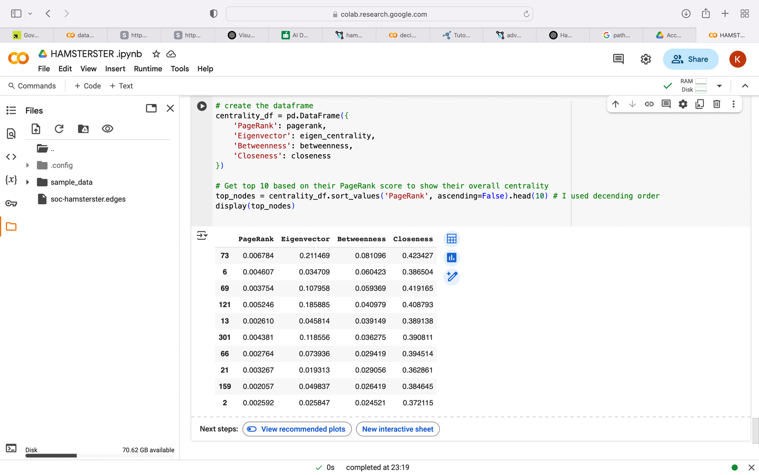

Node 73 played a major role in constructing the network, and according to all measures it is the most central node. It's a subgroup bridge (betweenness), well integrated in influential clusters (eigenvector), quickly connected to others (closeness), and extremely influential (PageRank). It is probably the network's central hub.

Node 121 also had high centrality on all measures as it's ranked 2nd in the dataframe, however, Node 6 had a different picture: it was a high-reach node and a bridge node, but it had little influence on other dominant nodes. Nodes like 301 and 69 seem to be balanced donors that increase network cohesion and communication.

Interestingly, Node 202 holds a high degree of eigenvector centrality with lower PageRank, indicating that it points to other prominent nodes even when not well linked. Finally, Although it has a lower influence ranking, Node 21 is within the top 10 because it has a strategic location and is near other nodes.

1. **Comparison with synthetized Networks Analysis :**
2. Degree distribution , Diameter and clustering coefficient :

In order to better understand the Hamsterster social network's structural features, I contrasted the Hamsterster graph with the three synthetic model graphs, WS, BA, and ER, using the core statistics. Each model was set to have similar node numbers and estimated mean degrees as the Hamsterster graph.

As we saw earlier in the degree analysis the right skewed structre of the degree distribution of the Hamsterster network was very similar to that of the Barabási–Albert (BA) model, which had a power-law distribution as well (see the figure below) . However, the Watts–Strogatz and Erdős–Rényi graphs had more central symmetrical degree distributions with their average degree peaking in their center.

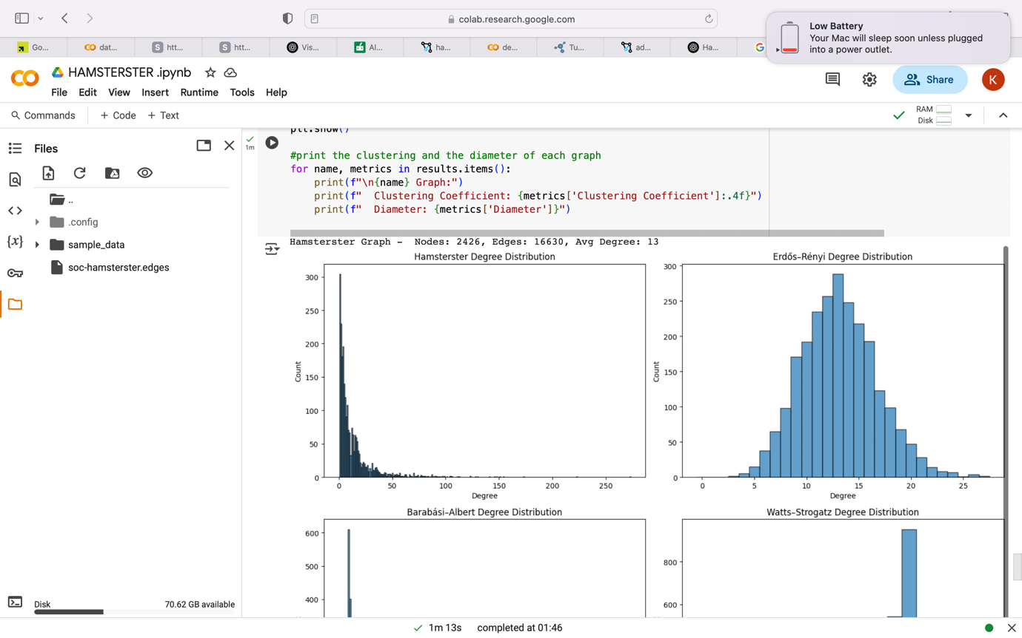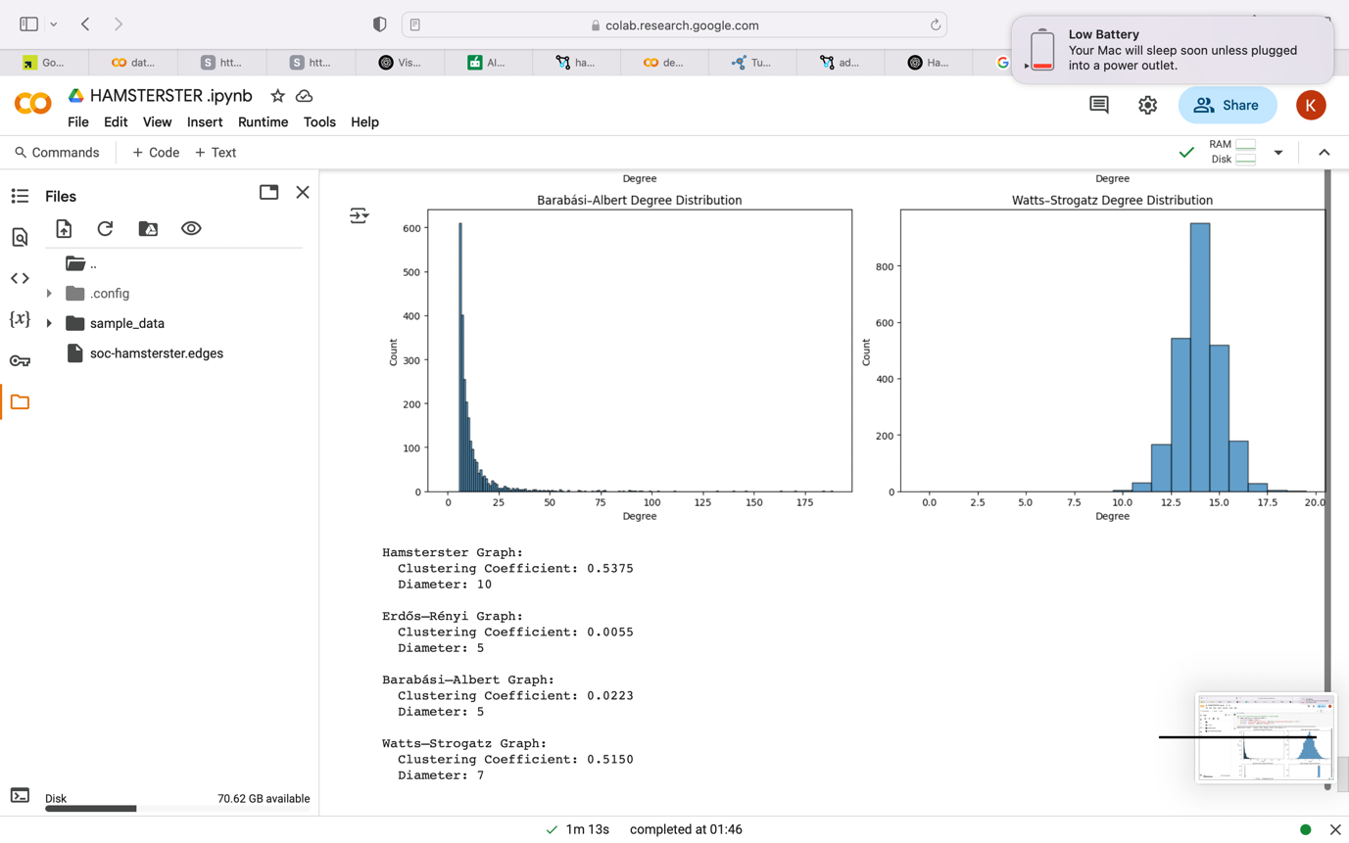

The code output:

Hamsterster Graph:

Clustering Coefficient: 0.5375

Diameter: 10

Erdős–Rényi Graph:

Clustering Coefficient: 0.0055

Diameter: 5

Barabási–Albert Graph:

Clustering Coefficient: 0.0223

Diameter: 5

Watts–Strogatz Graph:

Clustering Coefficient: 0.5150

Diameter: 7

Hamsterster's clustering coefficient was 0.5375, close to WS (0.5150) and much higher than ER (0.0055) and BA (0.0223). As usual with social graphs, this indicates the existence of dense communities in the real network.

By diameter, the Hamsterster network (10) was greater than WS (7) and greater than ER (5) and BA (5) . This indicates that in comparison to the synthetic models, the network structure has more distant node pairs, yet still possessing small-world properties.

By being a combination of hub-based and community-based network dynamics, the Hamsterster network embodies a hybrid structure that is longer in diameter, densely clustered like in WS, yet scale-free in degree.

1. Centrality metrics :

For this comparison I created a dataframe that store all the results of the analysis as shown in the figure below :

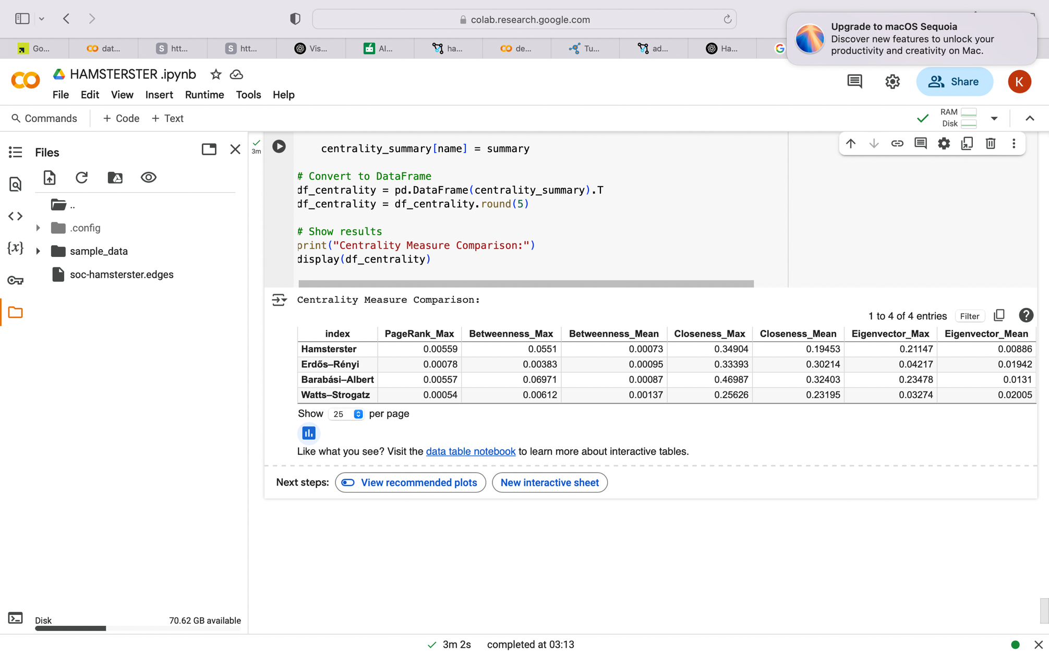

In addition to structured comparison, I also compared the four centrality metrics — PageRank, Betweenness, Closeness, and Eigenvector Centrality — in the Hamsterster network and the three synthetic models. A characteristic of scale-free networks, the presence of influential hub nodes was supported by the high maximum PageRank (0.00559) and Eigenvector Centrality (0.21147) of the Hamsterster network, which were comparable to those of the BA model.

In BA (0.06971) and Hamsterster (0.05510) networks, maximum betweenness centrality was also the highest, indicating that major nodes are serving as bridges. ER and WS models, on the other hand, featured more even, dispersed centrality values.

While it possess central hubs, the lower value of the Hamsterster network's average closeness indicates that it is less accessible globally compared to the BA and ER graphs, which were more connected . In general, Hamsterster network is structurally close to the BA model but is more centralized in its influence, supporting the theory that real-world social networks are heterogeneous and scale-free.

1. Robustness check: Highest-degree node removal :

In order to see the vulnerability of every network to certain attacks, we removed each time the graph's node with the highest degree and measured the size of the giant component. The outcome shows large variations in the levels of robustness for the models. The Hamsterster network was the most severely ollapsing one: its giant component totally crushed after less than 600 removed nodes. This explains that this network has a strong reliance on a small number of highly influential hub nodes, which quickly dissolved the network when they were removed.

Similarly, the scale-free Barabási–Albert (BA) model also crashed quickly, demonstrating how susceptible it is to the removal of high-degree nodes. The Erdős–Rényi (ER) and Watts–Strogatz (WS) graphs were more robust, however, and retained relatively large connected components after the removal process. And that's because these models have more homogeneous degree distributions which means that node importance is distributed more evenly throughout the network. I would say that this was expected.

This is the results of my code:

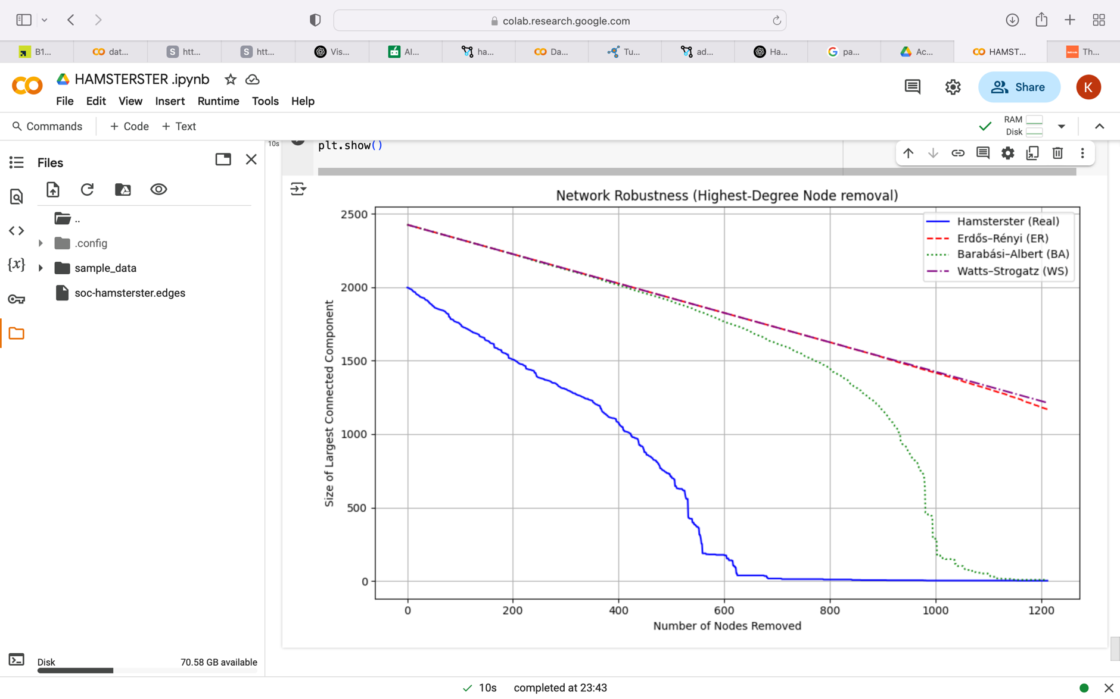

1. Robustness check : Most central node Removal :

We also carried out another check for the network robustness by iteratively deleting the node with the highest betweenness centrality, which quantifies nodes that are serving as significant bridges in the network, to further quantify network robustness. We tracked the size of the largest connected component and, at each step, removed the most central node and re-calculated centrality using an approximation approach to enhance efficiency. From the results, the Hamsterster network is extremely susceptible to this kind of attack; after fewer than 700 node removals, its giant component entirely fell apart. This serves to point out how the network is held together by a few structurally important nodes.

A sudden drop in the Barabási–Albert (BA) model further confirmed the well-known vulnerability of scale-free networks to centrality-based attacks. However, because of their more uniformly distributed centrality, which disabled any individual node from controlling the structure, the Erdős–Rényi (ER) and Watts–Strogatz (WS) networks were much more robust and dropped much more gradually.

Here are the code results :

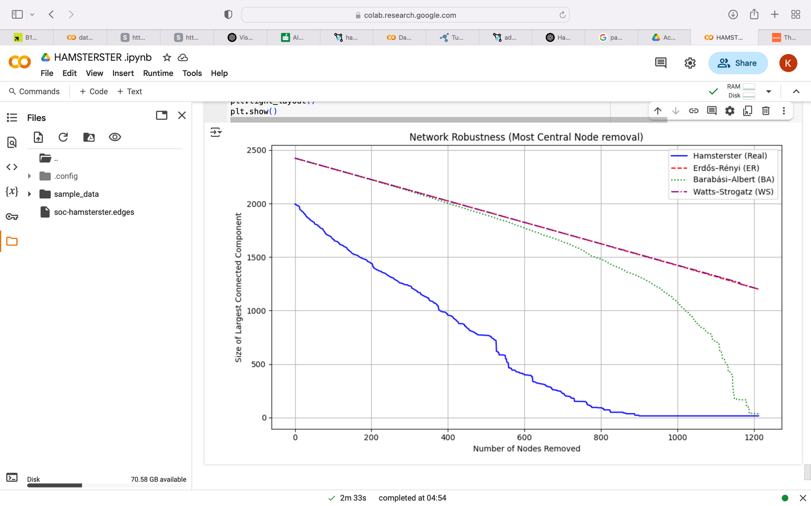

1. Robustness checks comparison:

Both degree-based and centrality-based attacks revealed the vulnerabilities of the BA and Hamsterster networks, although collapse under centrality-based removal came earlier and more intensely. From the point of view of resilience measurement, this implies that centrality is capturing more structurally significant nodes than in degree alone and highlights the importance of network flow and connectedness rather than node connectivity.

1. Louvain Community detection Method and modularity:

We used the Louvain community detection algorithm and calculated the modularity score, which measures the goodness of community structure, to determine how well each network tends to organize into communities. A higher modularity Iindicates More separated, more densely connected communities .

These are the results found for each network :

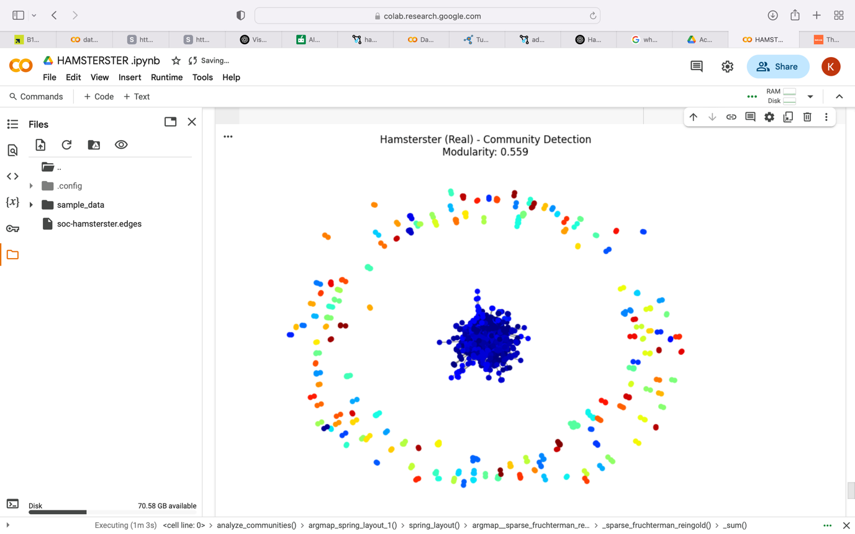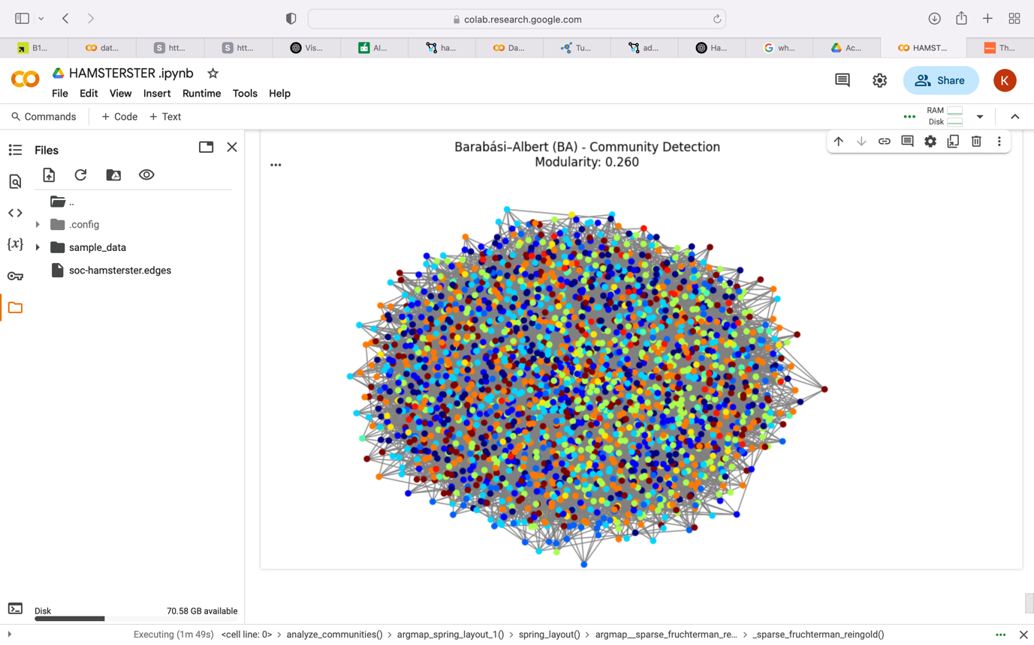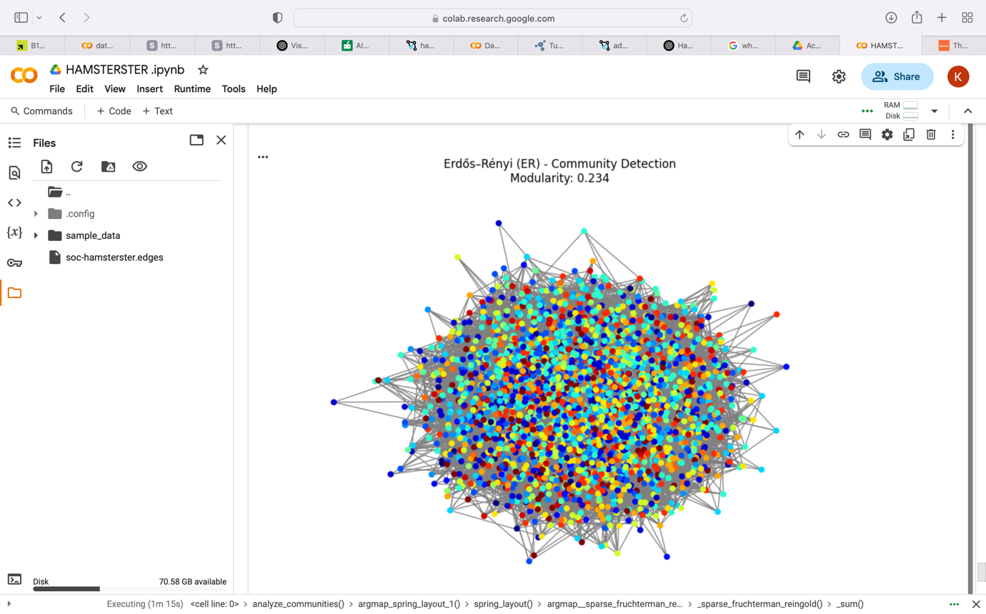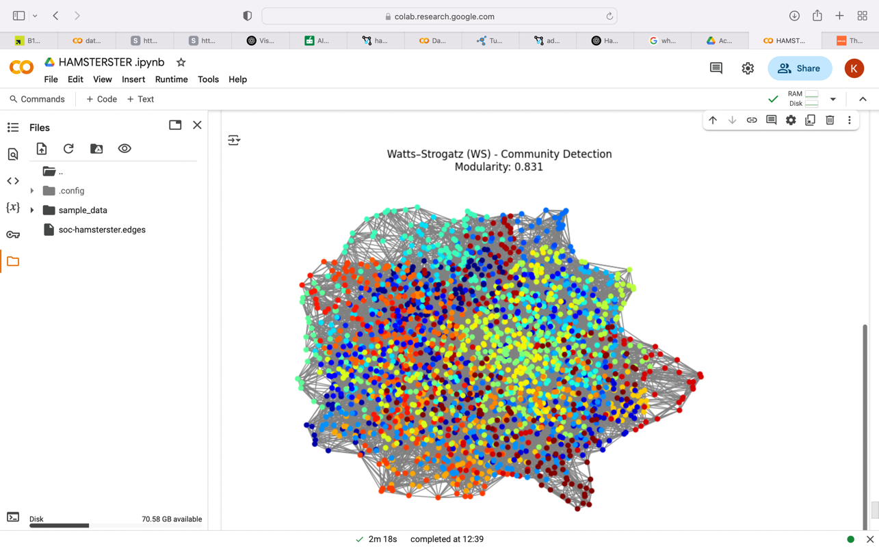

Now Let’s analyse these community graphs and their modularity score :

With the highest modularity (0.831), Watts–Strogatz (WS) network created well-structured and well-separated communities ( we can see the different colors of communities clearly ) .This is to be expected with its small-world structure, which finds the best possible balance between global shortcuts and local clustering. As in real networks is also witnessed in the Hamsterster network which was found to have a relatively high modular structure (0.559) that implies members tend to cluster into somewhat differentiated social groupings.

The Erdős–Rényi (ER) and Barabási–Albert (BA) networks, on the other hand, provided lower modularity values (0.234 and 0.260, respectively), which indicate weaker or less differentiated community organisation. Although BA is dominated by a limited number of hubs, ER's random edge structure leaves little internal clustering. The current findings are evidence for the more robust and larger-scale community structures found in real and small-world networks compared to fully synthesized or randomly generated networks.

1. **Linear Threshold Model Analysis for Maximising the spread of influence :**

To investigate influence propagation within networks, we implemented the Linear Threshold Model (LTM) where it shows the activated nodes in green , seed nodes in red and inactivated nodes in blue .

1. Linear threshold model for the Hamsterster network :

I used the Hamsterster network in the LTM I developed to compare the impact of four centrality-based strategies:

* Degree Centrality (node with the highest degree )
* Betweenness centrality
* closeness centrality.
* PageRank

Having determined the seed size to be ten nodes, I was able then to see how the influence spread throughout the network , see the figure below . In comparison to PageRank, which performed poorly in this instance, the simulations demonstrate that degree and betweenness centrality measures typically activate a much greater proportion of the network. This suggests that, particularly in real-world social networks like Hamsterster, highly structurally connected or bridging nodes are essential for influence spreading.

This is a screenshot from my code results which helped me identify the influence :

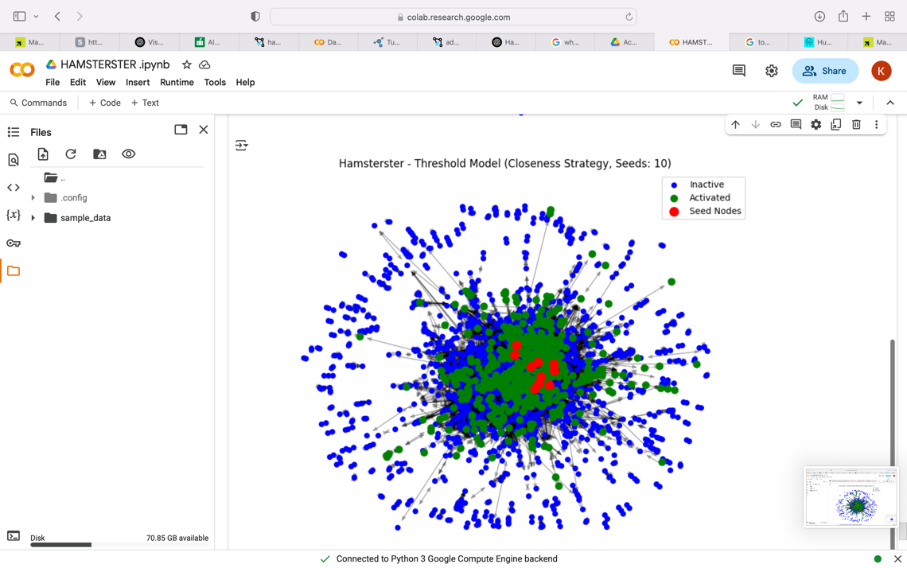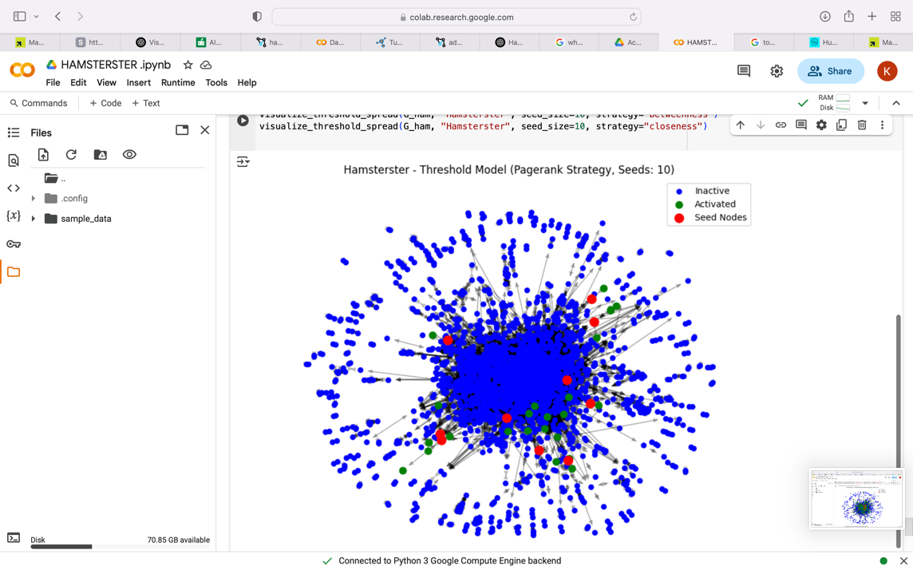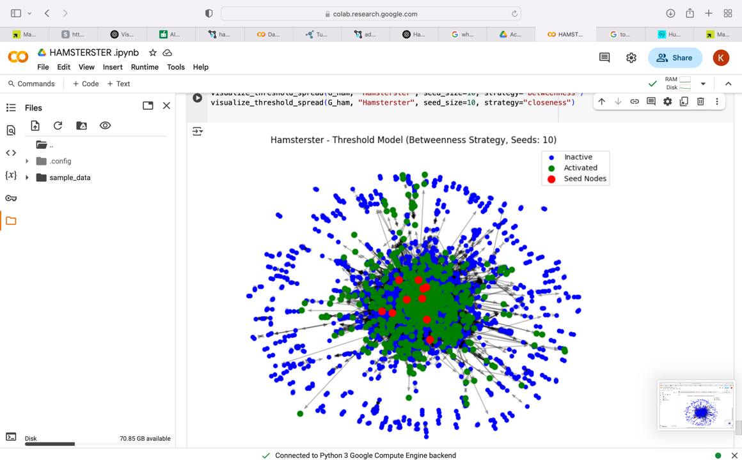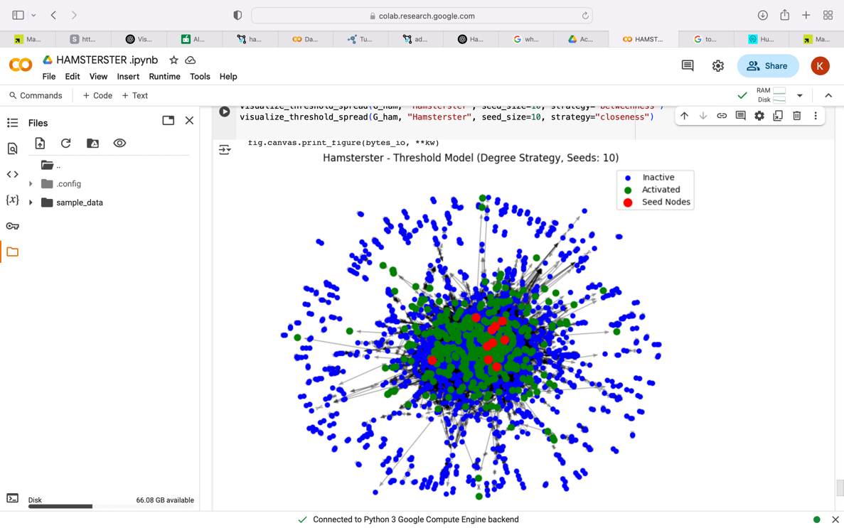

1. Linear Threshold model based on highest degree node for the 4 networks :

I applied the Linear Threshold Model (LTM) for the 4networks to study network structure influence on diffusion dynamics. I did this by choosing the top k nodes by degree as seed nodes. Influence spread was measured with seed sizes of 5, 10, 20, 30, and 100.

The code printed outputs :

Hamsterster | Seeds: 5 → Activated: 263

Hamsterster | Seeds: 10 → Activated: 605

Hamsterster | Seeds: 20 → Activated: 720

Hamsterster | Seeds: 30 → Activated: 1040

Hamsterster | Seeds: 100 → Activated: 1351

Erdős–Rényi | Seeds: 5 → Activated: 108

Erdős–Rényi | Seeds: 10 → Activated: 216

Erdős–Rényi | Seeds: 20 → Activated: 282

Erdős–Rényi | Seeds: 30 → Activated: 572

Erdős–Rényi | Seeds: 100 → Activated: 1198

Barabási–Albert | Seeds: 5 → Activated: 1176

Barabási–Albert | Seeds: 10 → Activated: 983

Barabási–Albert | Seeds: 20 → Activated: 1394

Barabási–Albert | Seeds: 30 → Activated: 1319

Barabási–Albert | Seeds: 100 → Activated: 1725

Watts–Strogatz | Seeds: 5 → Activated: 18

Watts–Strogatz | Seeds: 10 → Activated: 121

Watts–Strogatz | Seeds: 20 → Activated: 136

Watts–Strogatz | Seeds: 30 → Activated: 270

Watts–Strogatz | Seeds: 100 → Activated: 580

The findings indicate great differences in spread efficiency. Among all the graphs provided, 100 seeds and 1725 nodes, the Barabási–Albert graph always had the maximum spread due to its scale-free nature and the hub nodes. Realistic clustering from Hamsterster showed community structure by having constant influence spread increase despite low efficiency. Watts-Strogatz showed minimal spread whereas more random Erdős-Rényi needed larger seed sizes for large activation regions within the network. This means that its high clustering but small-world character may prevent the spread of influence under the LTM.

This line chart is also implemented in my code to help visualise the results and make useful comparison :

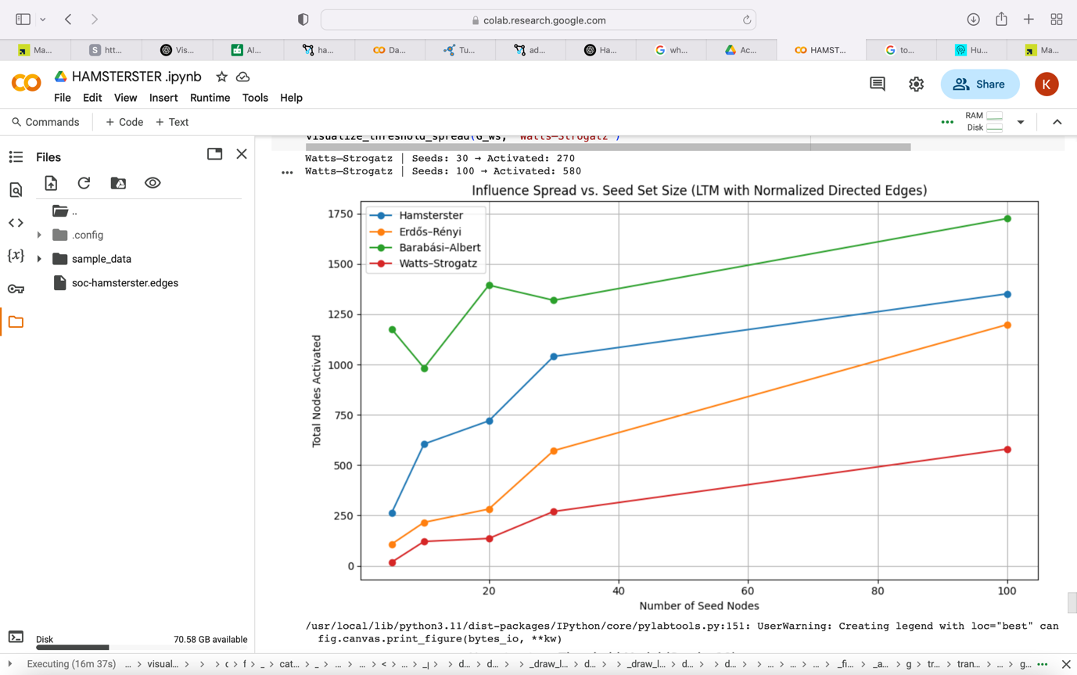

In general, the analysis shows how network structure plays a role in diffusion, and that the attack on high-degree nodes is most effective in scale-free networks like Barabási–Albert, but perhaps not sufficient in more evenly random or clustered structures like Erdős–Rényi and Watts–Strogatz

REFERENCES :

In my report I mainly use the code I generated through the whole class and also the class presentations

**Works Cited**

Barabási, Albert-László, and Réka Albert. “Emergence of Scaling in Random Networks.” *Science*, vol. 286, no. 5439, 15 Oct. 1999, pp. 509–512, https://doi.org/10.1126/science.286.5439.509.

---. “Emergence of Scaling in Random Networks.” *Science*, vol. 286, no. 5439, 15 Oct. 1999, pp. 509–512, https://doi.org/10.1126/science.286.5439.509.

Heller, Nathan. “It Was Obama’s Year on Twitter.” *The New Yorker*, 5 Dec. 2017, www.newyorker.com/culture/cultural-comment/it-was-obamas-year-on-twitter. Accessed 20 Mar. 2025.